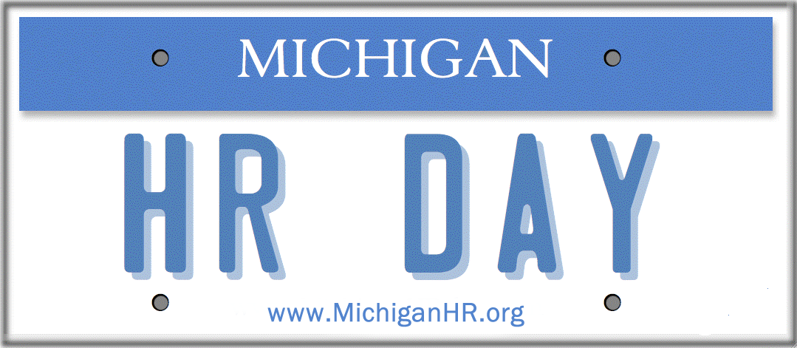

Organization Name

Sponsorship Agreement
10th Annual Michigan HR DAY – April 11, 2019 Connecting HR Leaders, Professionals, and Resources Lansing Center - Lansing, Michigan

Contact Name/Title

Address
Phone/Email
Michigan HR Day provides HR professionals in Michigan an opportunity to exchange information, ideas, and experiences. Positioned at a critical time for Michigan organizations, the event addresses the relevance of the HR function as an important part of Michigan’s economic gardening and revitalization. Michigan HR Day welcomes HR professionals from diverse Michigan organizations a true reflection of the State’s business environment and culture.

SPONSORSHIP LEVELS (Please check one)

____ Level 1 $5,000 Feature Sponsor
  - Includes 20 paid admissions to Michigan HR Day
  - Recognition as feature sponsor for the day
  - Limited to one organization
  - Full page ad in MI HR Day Program
  - Benefits listed under Levels 2, 3, & 4

Level 2 $2,500 Program Sponsor
  - Includes 10 paid admissions to Michigan HR Day
  - Includes enhanced recognition and premium advertising/marketing of your organization throughout HR Day
  - Limited to 4 organizations
  - 1/2 page ad in MI HR Day Program
  - Benefits listed under Levels 3 & 4

Level 3 $1,000 Network Sponsor
  - Includes 5 paid admissions to Michigan HR Day
  - Access to contact information for conference attendees
1/4 page ad in MI HR Day Program
  - Benefits listed under Levels 4

Level 4 $500 Organizational Sponsor
- Includes 3 paid admissions to Michigan HR
- Information table in exhibit hall with selection of placement
- Name on website with link to company website
- 1/8 page ad in MI HR Day Program

- RAFFLE PRIZE CONTRIBUTIONS: If interested in donating a raffle prize you will be recognized at HR Day and also recognized on our website and on all printed material. Please let us know what you would like to donate to the raffle below and return form to Michigan HR. (Please note that donating a prize if you are a sponsor is optional and you can donate even if you are not a sponsor)
**In order to be recognized on all printed material, you must be registered by March 16, 2019

TERMS/FORM OF PAYMENT: Payment is due with this agreement. Please enclose check made payable to “Michigan HR”.

MAIL PAYMENT & AGREEMENT TO:
Darci Hoag
MI HR Treasurer
P.O. Box 663, Saline, MI 48176

QUESTIONS MAY BE DIRECTED TO:
Darci Hoag or Sara Barton
mihrsponsors@gmail.com

www.MichiganHR.org MichiganHR Michigan HR @MichiganHR

